DSA 301 PROJECT 1
Sami Emir Arslan
Task 1
A) Map of Türkiye with Time Series
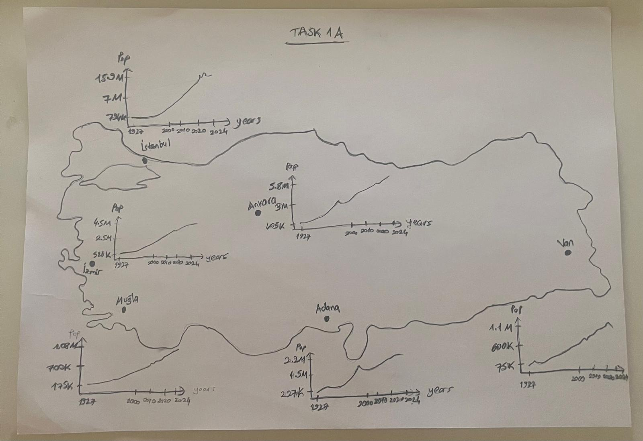
Classification in terms of Population: Big cities (İstanbul, İzmir, Ankara) and small cities(Van, Adana, Muğla)
B) 3 Socio-Economic Indicators of Türkiye from TUIK
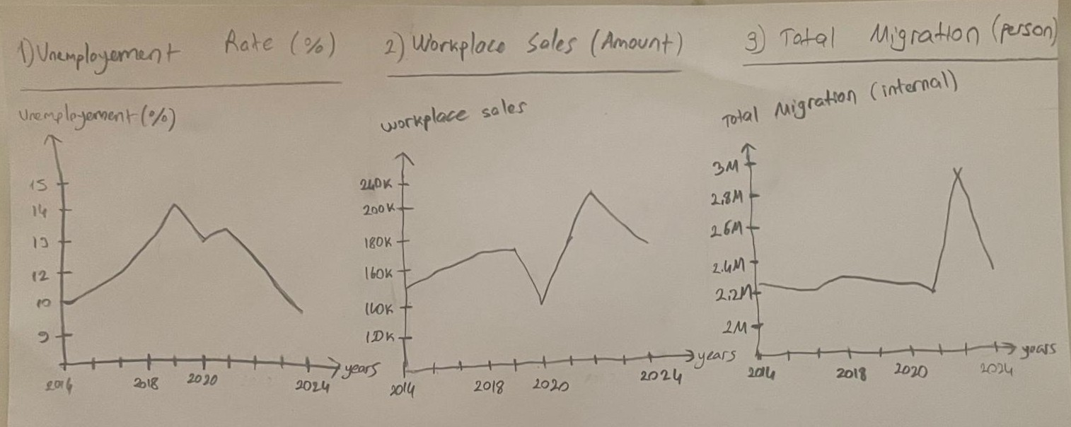
Three socio-economic indicators were selected from the TÜİK database for the period 2014–2024:
• Unemployment Rate
• Workplace Sales
• Annual Migration (Internal)
C) Formulated Question
“Do unemployment and workplace sales trends affect migration differently in crowded cities (İstanbul, Ankara, İzmir) compared to less populated cities (Muğla, Adana, Van) in Türkiye between 2014–2024?”
Task 2
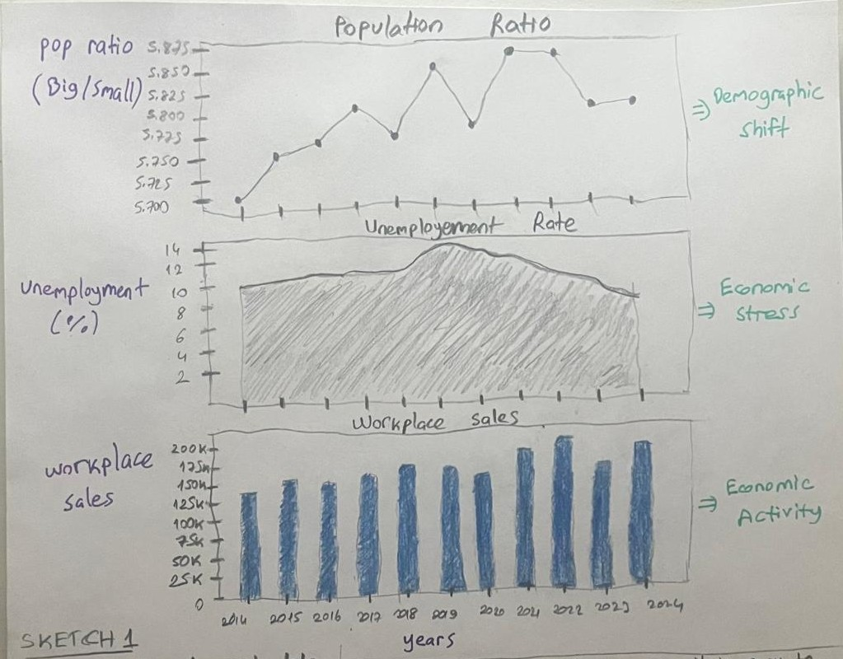
SKETCH1: Multi-Line Time Series
Note
Population ratio was calculated by summing the annual population of the big cities and dividing it by the population of the small cities for each year. This ratio enables interpretations regarding migration patterns.
How it answers the question?
This visualization helps by showing whether changes in unemployment and workplace sales occur during the same periods as migration-related demographic changes.
The viewer can easily compare trends because all variables share the same time axis.

Design decisions and rationale
I used line marks for representing demographic shift,
indicated area to emphasize economic pressure,
bar plots to show annual totals clearly,
used the horizontal axis to encode time,
used vertical axis to show the magnitude of the values,
used line charts because it is one of the most effective ways to visualize changes over time.
The visualization uses position on a common scale, which is one of the most effective visual channels for comparing quantitative values.
I tried to maintain high data-ink ratio to feature meaningful data.
Usefulness
It could be used in seminars, class presentations, or scientific reports, when explaining how economic and demographic indicators move across time.
Strength
It is easy to read and interpret, clearly shows the overall trends, peaks and declines.
Weakness
Relationship between variables is not always obvious, some trends might overlap visually.
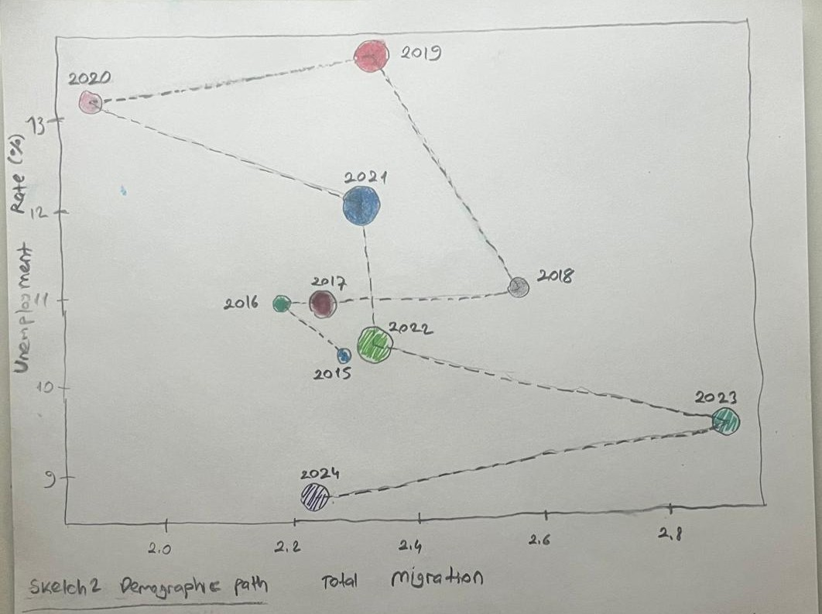
SKETCH2-Demographic Path
How it answers the question?
This sketch answers the question by showing each year as a changing demographic state that evolves over time.
It provides the visualization of how unemployment and migration move together, while workplace sales change in relation to them. This structure makes it easier to follow how these variables interact.

Design decisions and rationale
used horizontal axis to show migration values,
used vertical axis to represent unemployment rates,
used bubble size to represent workplace sales,
connected each year with dashed line to maintain chronological order.
My main goal for this visualization is combining three variables into single view, allowing relationship between them to become more visible.

Usefulness
It might be useful for analytical representations, research reports that aim to explain demographic and economic connections over time.
Strength
The main strength is that three variables are integrated into one visualization. Compared to Sketch 1, it provides a more compact and informative representation of the relationship between variables.
Weakness
Bubble area is used as an encoding channel, but when comparing values, area is less precise than length or position. This may make the visualization more complex.
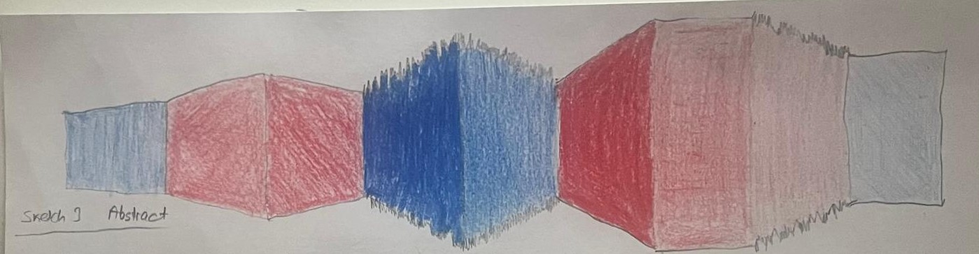
SKETCH3- Abstract Streamgraph
How it answers the question?
This sketch answers the question in a more abstract way.
Apart from sketch 1 and sketch 2, this visual does not show exact numerical values. Instead, it focuses on showing the overall relationship between demographic shifts, migration patterns, economic pressure, and workplace sales (economic activity).
All the variables are encoded within the visualization providing a clear overview of the data.
Design decisions and rationale
The width encodes population ratio,
Color hue encodes migration direction: Red equals migration increased,
Blue equals migration decreased.
Colour saturation encodes unemployment level, higher saturation indicates higher unemployment.
Edge texture encodes workplace sales changes. Jagged edges mean “workplace sales dropped”,
smoother edges means “relatively more stable sales”.
This design uses preattentive visual features like colour contrast and shape variation, which allow viewers to realize instant changes more quickly.
While designing this sketch, I benefited from proximity and continuity which are Gestalt principles. For example, the stream-like shape creates a continuous path across years and each segment is located close to the next, supporting the idea that they belong to the same sequence.

Usefulness
This visualization could be useful for presentations, especially at the end, when you want to give an overall interpretation of the data, it can be very effective.
Strength
Its most prominent strength is the ability to represent multiple variables simultaneously, making complicated patterns easier to observe.
Weakness
Low numerical precision is the biggest weakness for this model. Exact values cannot be read directly so the visualization requires additional explanation.
Task 3
Implementation
For the final implementation, I chose Sketch 3 (Abstract Streamgraph).
I created the visualization as a standalone HTML file with JavaScript inside it, thus it can be opened directly in any web browser without installing extra libraries or software.
The coded visualization transforms my abstract sketch into a data-based visual structure. Each segment represents one year between 2014 and 2024. These segments are placed next to each other horizontally, creating a continuous stream-like shape, which follows the idea of the original hand-drawn design.
Encoding Used in the Implementation
Segment width represents the population ratio between crowded and less populated cities, showing how demographic density changes over time.
The width encodes population ratio,
Color hue encodes migration direction: Red equals migration increased,
Blue equals migration decreased.
Color saturation encodes unemployment if saturation is high meaning that unemployment is high.
Edge texture encodes workplace sales changes. Jagged edges mean “workplace sales dropped”,
smoother edges mean “relatively more stable sales”.

The visualization page is organized in a two-panel layout:
The left panel shows the original hand-drawn sketch,
The right panel shows the coded visualization.
This layout allows the viewer to easily compare the initial design idea with the final implemented version.
Github link: https://github.com/Emir344/DSA301-Project1/
